Student Profile

Joyce Dussault | E-mail: jd@myemail.com | 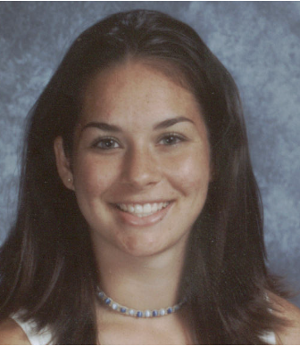  Jersey # 15  Forward, Midfield
1845 Summit Ave | DOB: 08-19-93
Plano, TX 75074 | Student ID: 11111
Tel: 866-829-2606 | Height: 6’ 0”
Parents: Henri & Sherri | Weight: 145 lbs.

College Career Objective
My goal is to pursue a degree in business or education. I really enjoy helping and working with people. Athletically, I love Soccer and have a drive and passion for excellence on and off the field. I am they type of player who is committed to taking responsibility and doing my job to help make my team a success

Academic & Entrepreneurship Club Soccer, Tournaments & Camps
Graduation: Class of 2009

School: Nolan Catholic College Preparatory
Address: 4501 Bridge St.
Fort Worth, Texas 76103
Phone: 817-294-9514
SAT: 1800
GPA: 4.0B Class Rank: 14/1260
Honors and Advanced Courses
AP History, Math, Science, Physics & Economics
Honors Algebra; Honors Geometry; Honors Algebra II; Honors Spanish III

Awards & Achievements
- A Honor Roll 2005-2009
Employment
Co-Founder – Sitters Unlimited
Child Care Service – Baby Sitting Service
Spring ’03 - Present
CLUB EXPERIENCE
TSS SOCCER – Dallas, Texas
U-17 Division 1, Lake Highlands Classic League
Coach: Mike Vincent
Phone: (Home) 817-111-0000; (Cell) 817- 111-1111
Email: sports@thesportsource.com
Position: Forward/Center Midfield
Other: Sweeper

Tournaments and Camps
- 2008 – Notre Dame Elite Camp
- 2008 – Plano Labor Day Invitational, Plano, TX
- 2008 – The Sport Source Showcase, Dallas Texas

Coach Vincent's Notes - Phenomenal work ethic. Joyce has the versatility and flexibility to play effectively in almost every position on the field. Solid with both feet; she should have no problem adapting to the technical, tactical, physical and psychological demands of the collegiate game. She personifies "Team".

High School Soccer References and Community Service
Nolan Catholic High School

2002 –Present: Varsity -Forward/Midfield

Coach – Arnel Bulaoro
Phone: 817-817-000-0000
Email: sports@thesportsource.com

Team Achievements

- 2008 – State Champion - Division 1

- 2007 – State Finalist - Division 1
Personal Achievements:

- 2009 – All District 2nd Team
- Only freshman to play during 2005 Playoffs
- Scored golden goal as freshman to win
State Championship

Additional References:
- Candice Robinson, Head Women’s Soccer Coach
My College University
(555) -121-1111; Email: sports@thesportspurce.com
- Lisa Lavelle –Mentor
(972) –509-5707 – Email: sports@thesportspurce.com

Community Service
- Mayfest –Community Fundraiser – Volunteer ’02-‘04
- Child Advocates of Fort Worth – Volunteer ’02-‘04
- St. Andrew’s Catholic Church –Eucharistic Minister
- Ft. Worth FC – Volunteer Youth Trainer

